Create and edit a file we use command

Vi file_name



Then file open like this and edit the text in the file

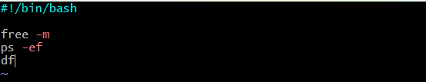

Then change the permissions of file command is

Chmod 777 file_name



Then execute the file with bash command

./file_name or bash file_name

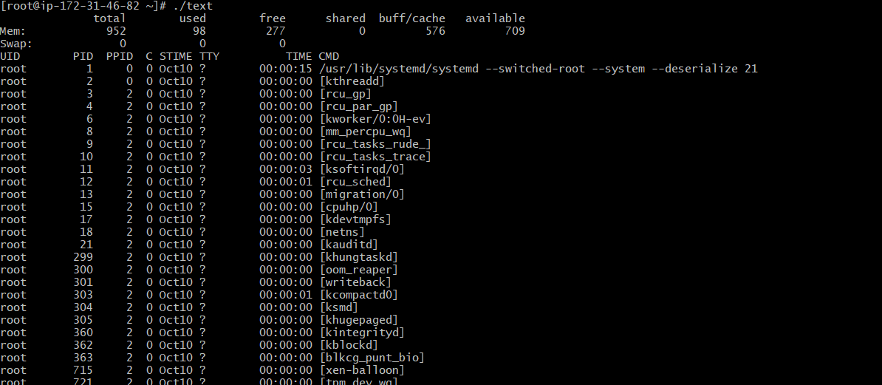

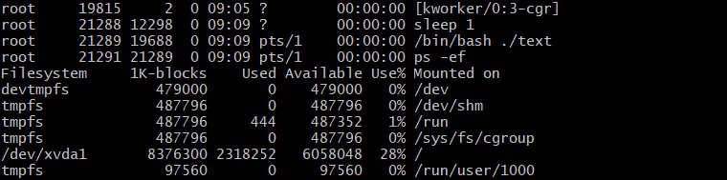

To know which shell am I using command is

echo $0



To know How many shells available in my system command is

Command is **cat /etc/shells**

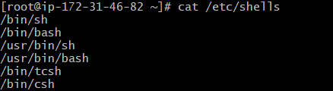

To change the shell command is **shellname(like sh, bash, csh,tcsh)**



To exit from the shell use command **exit**



To view present working directory use command **pwd**



To make new directory command is **mkdir directory_name**



To change the directory use command **cd name/path**



Create a file for scripting **vi file_name**



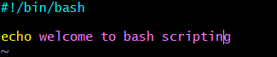

Change the permissions to the file **chmod 777 file_name**



To check the permissions, and all information about the file we use command **ll**



Permissions are changed what we given above..

Then execute the file command **./file_name or bash file_name**

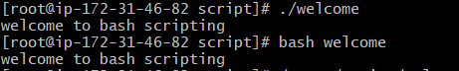

If we don’t given the permissions to a file then the permission is denied while we executing the command



1) Define shell (#!/bin/bash)

2) Comments (# comments)

3) Define vairbales ( e.g name=sabair)

4) Commands (echo ,cp ,grep etc.)

5) Statements (if,while,for etc)

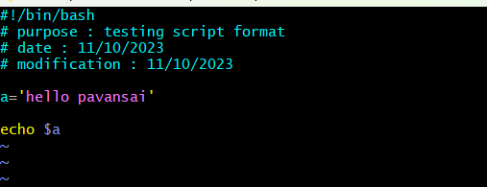

Sequence script:

===============

Script will execute from top to bottom

Ex:

ls

date

history

it will print in ascending order

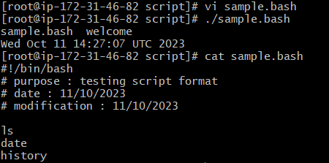

To show pwd,ls,date whoami

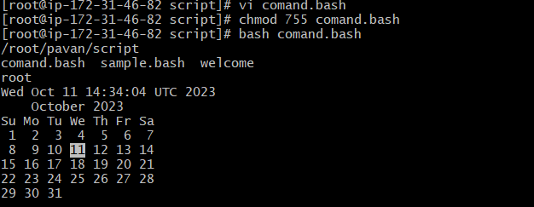

To show

top | head -10

df -h

free -m

uptime

iostat

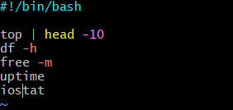

Then execute the command it shows like below

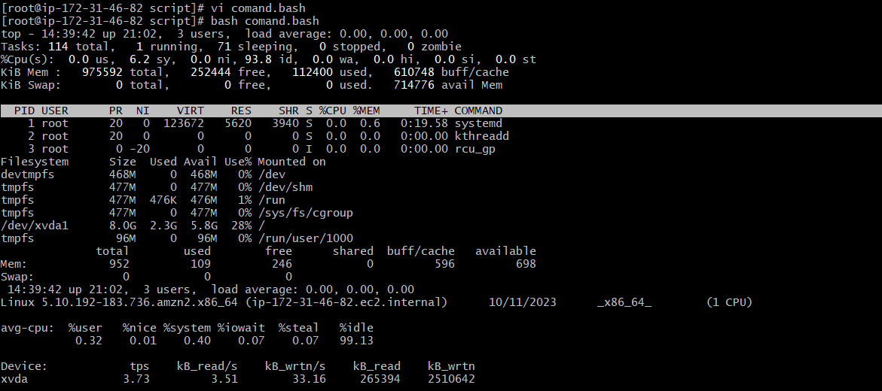

To define the variables

#!/bin/bash

#Define Variables

p=pwd

l=ls

wi=whoami

d=date

c='cal 2023'

echo Run Variables tasks

echo

$p

$l

$wi

$d

$c

Create a file and give the permissions and give the inputs as above mentioned

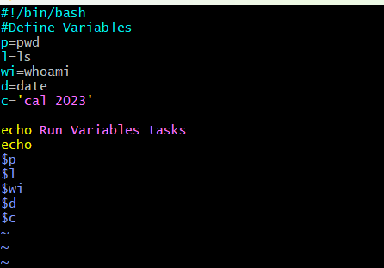

Execute the command and shows as like this

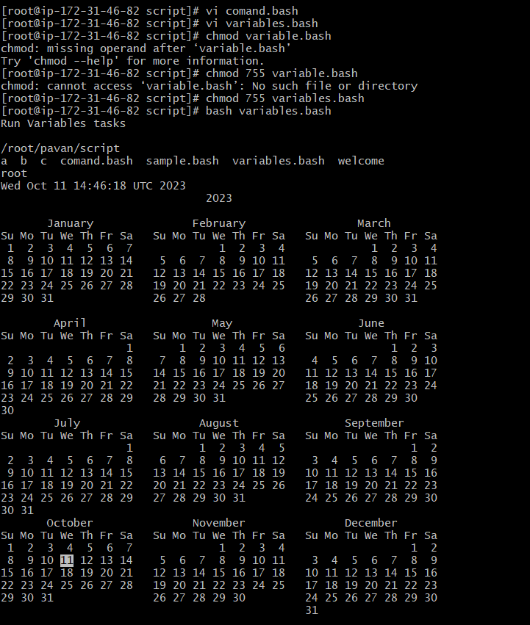

Input/output script

#!/bin/bash

echo Hello, my name is pavansai

echo

echo what is your name?

read name

echo

echo Hello $name

echo

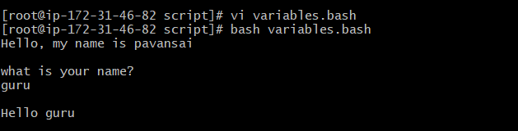

To view hostname or any name with in the system we use 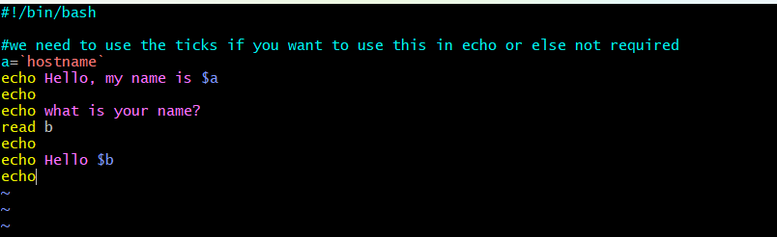

Then run this command it shows hostname

